Introduction to Amazon Simple Storage (S3)

Topics Covered:

1. Create a bucket in Amazon S3
2. Add an object to your bucket
3. Manage access permissions on an object
4. Create a bucket policy
5. Use bucket versioning

Lab:

1. Start Lab

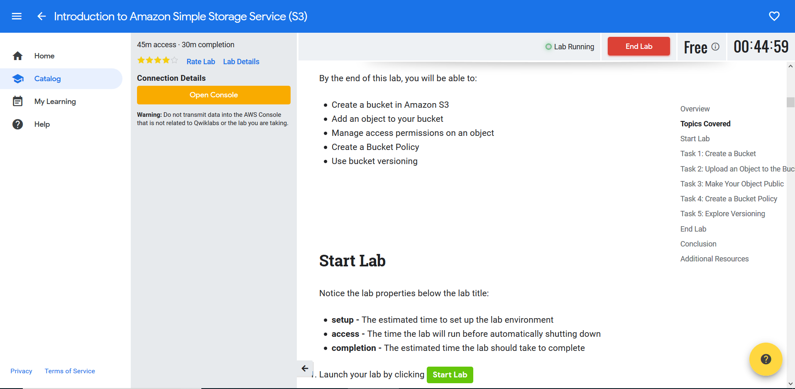

1. Create a S3 bucket
   1. with Bucket name : “mybucket300987” with Region as default
   2. Click Next and enable Versioning
   3. Click Next and keep default in manage Permission section
   4. Review and click Create Bucket

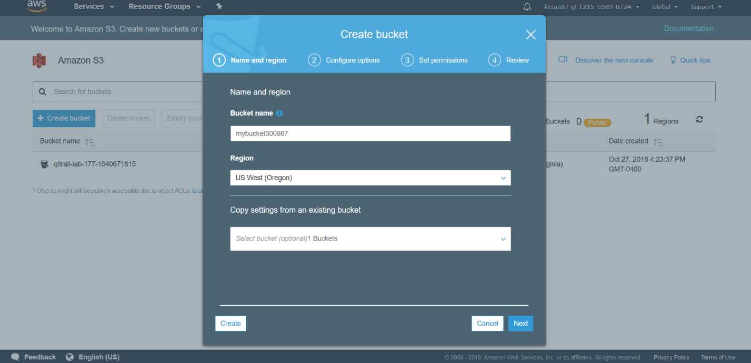

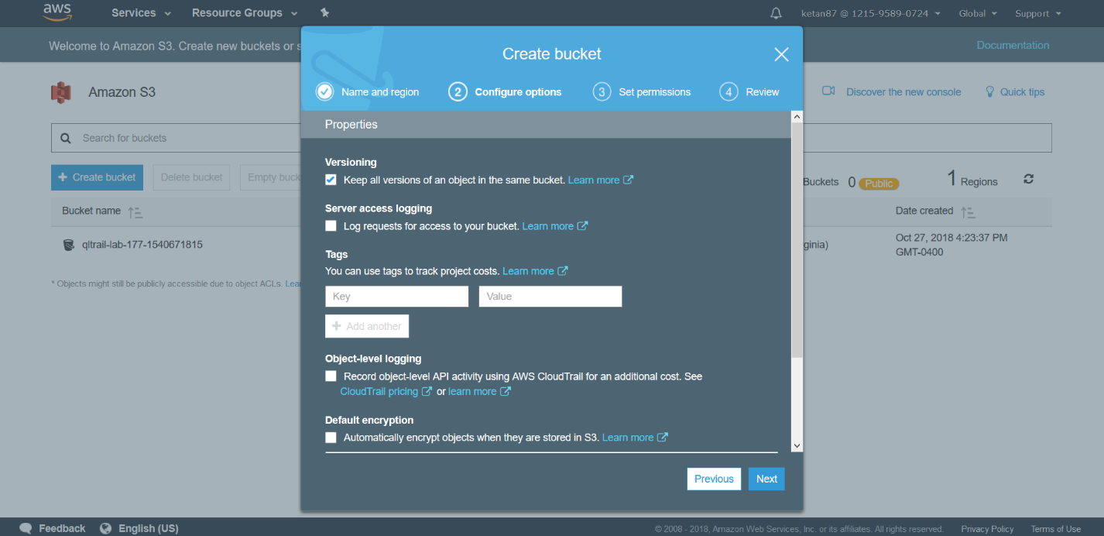

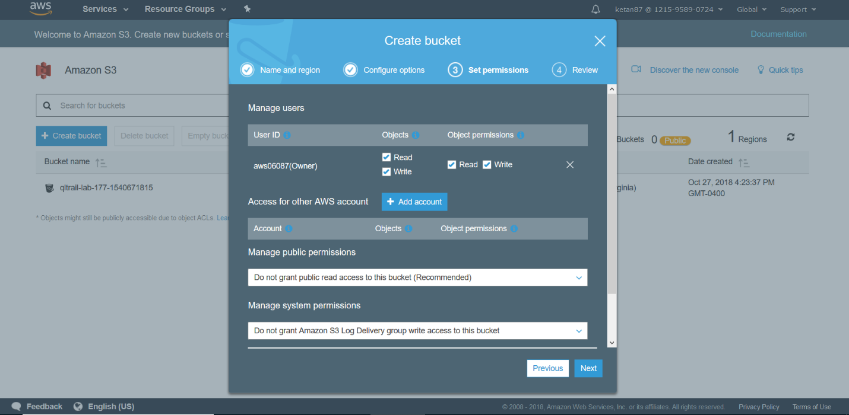

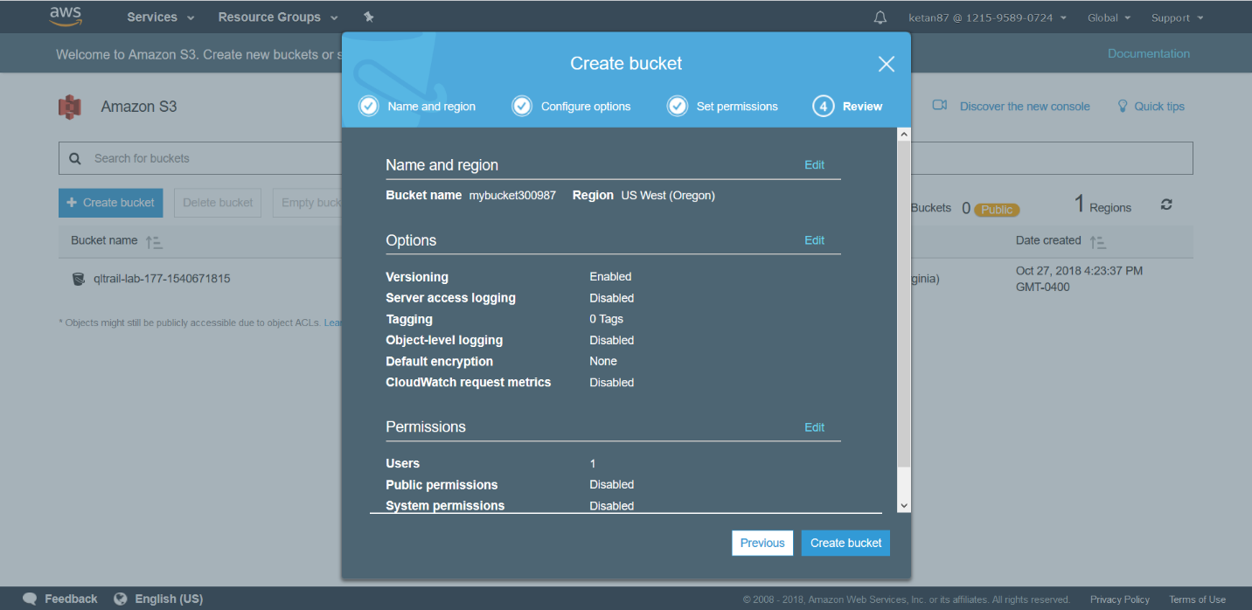

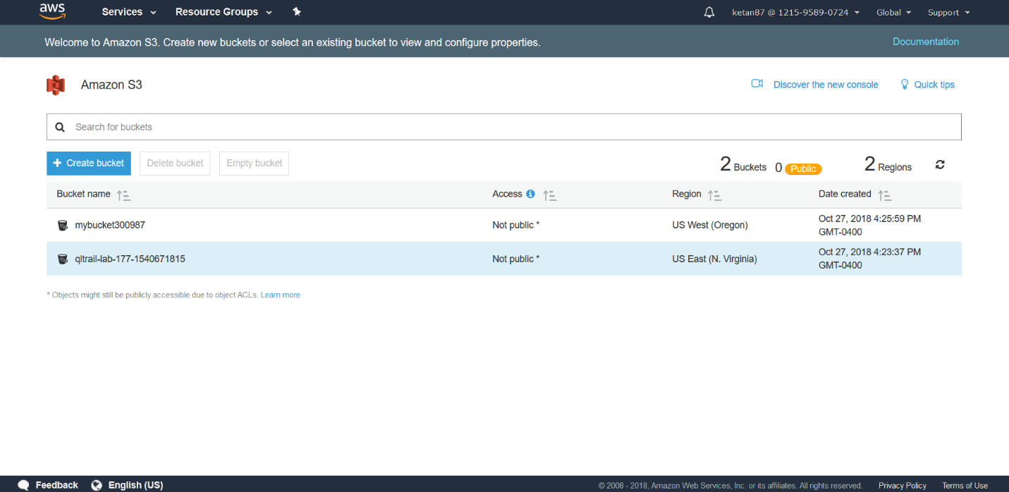

1. Upload an object to the Bucket
   1. Upload “Sheep.jpg” in the S3 bucket created above

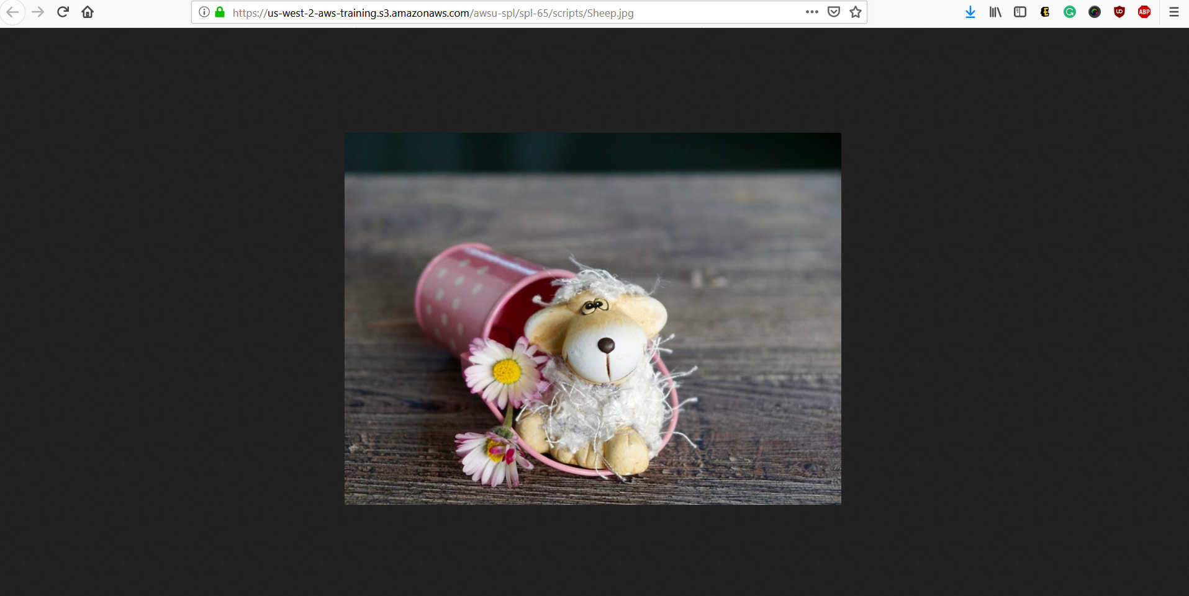

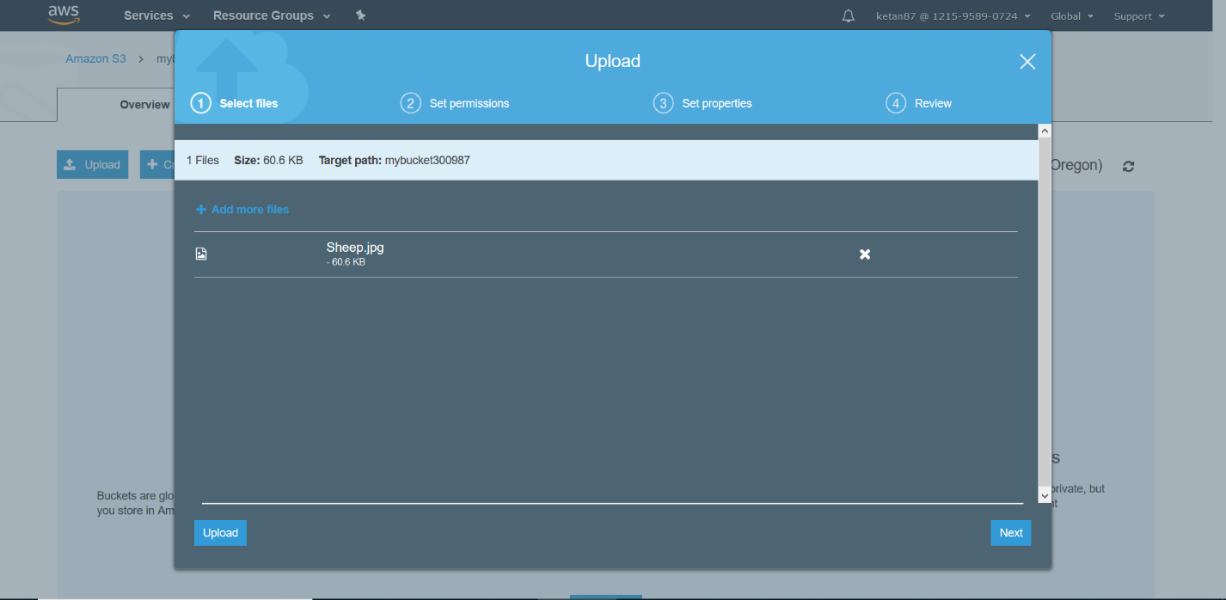

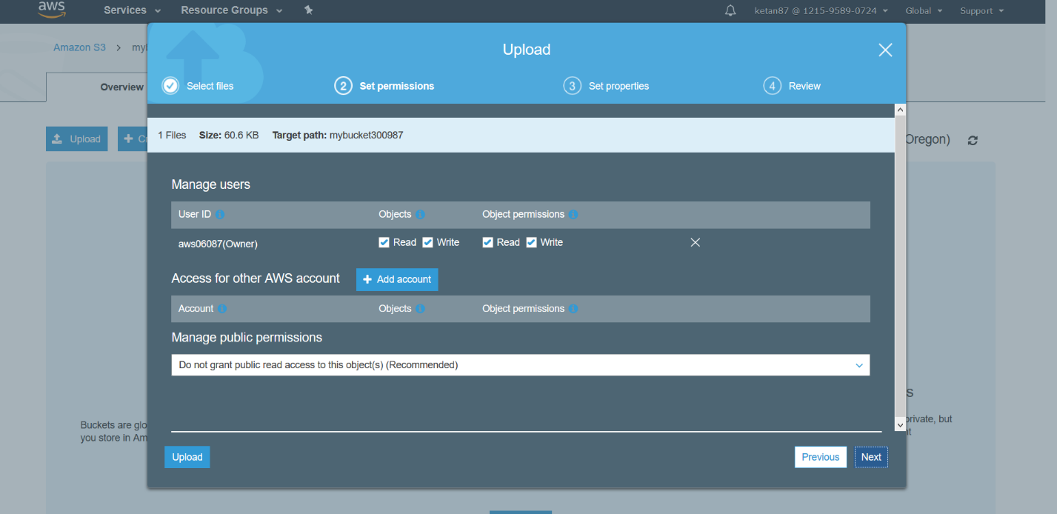

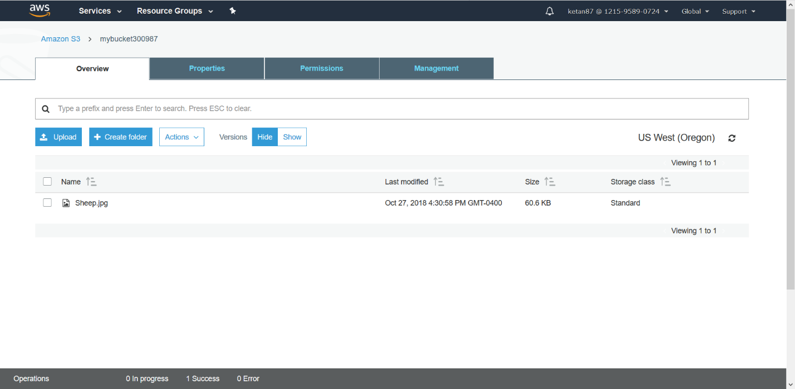

1. Make your Object Public
   1. Obtain the S3 link for the Sheep.jpg
   2. You should see Access Denied Error when opened in browser as the object is private by default
   3. In S3 console window, click the permissions tab of “sheep.jpg” object and under Public Access select Everyone and give read object access
   4. Click Save
   5. Open the S3 link in the browser. The image should be accessible publicly

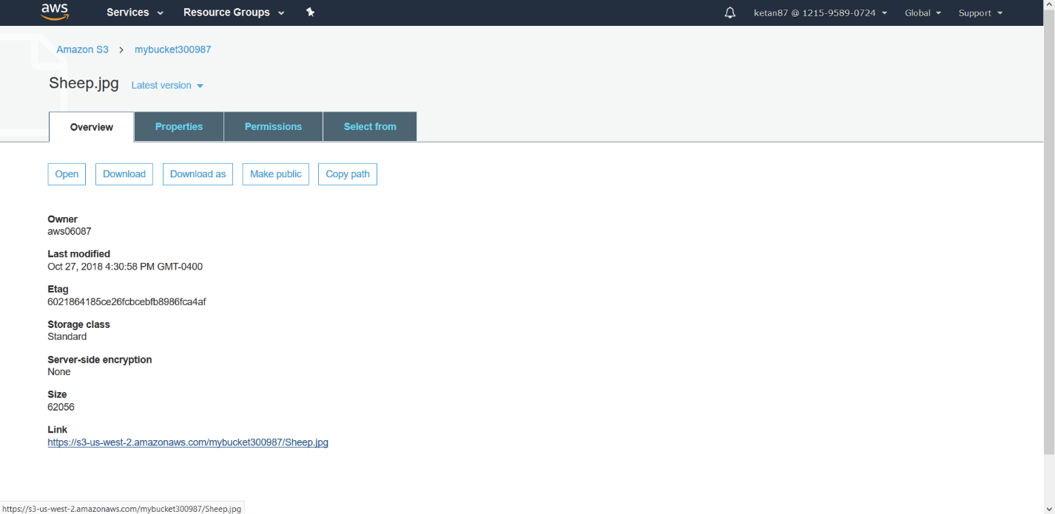

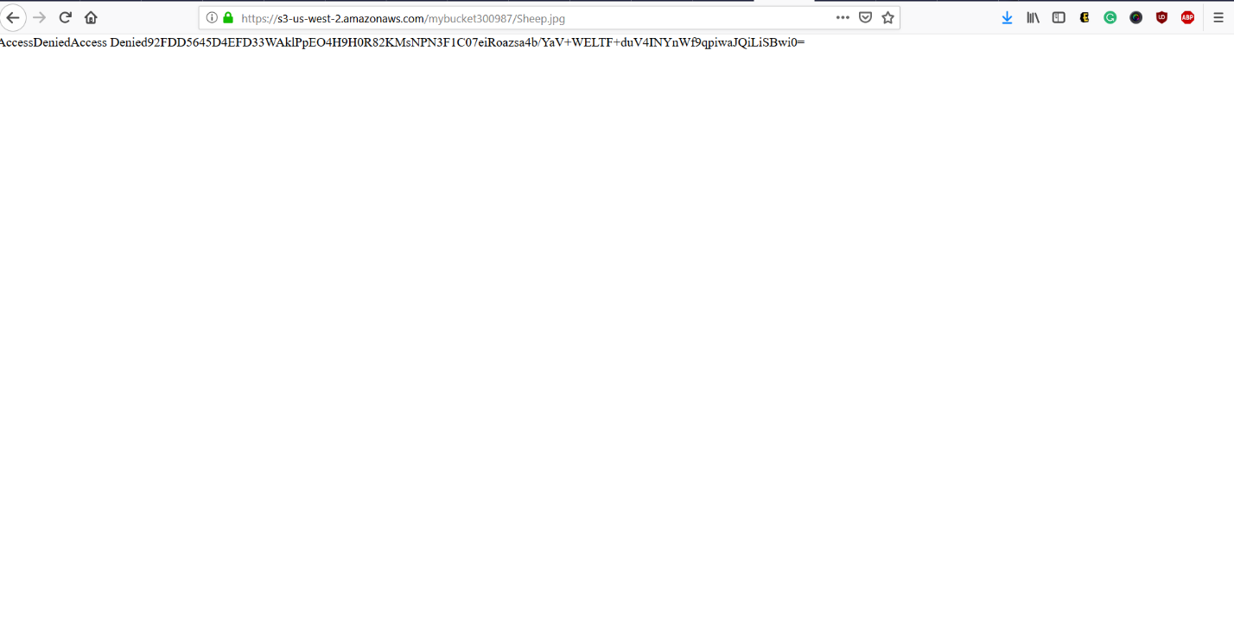

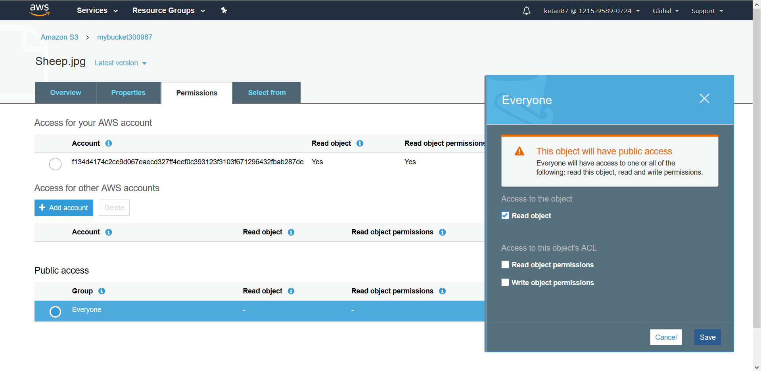

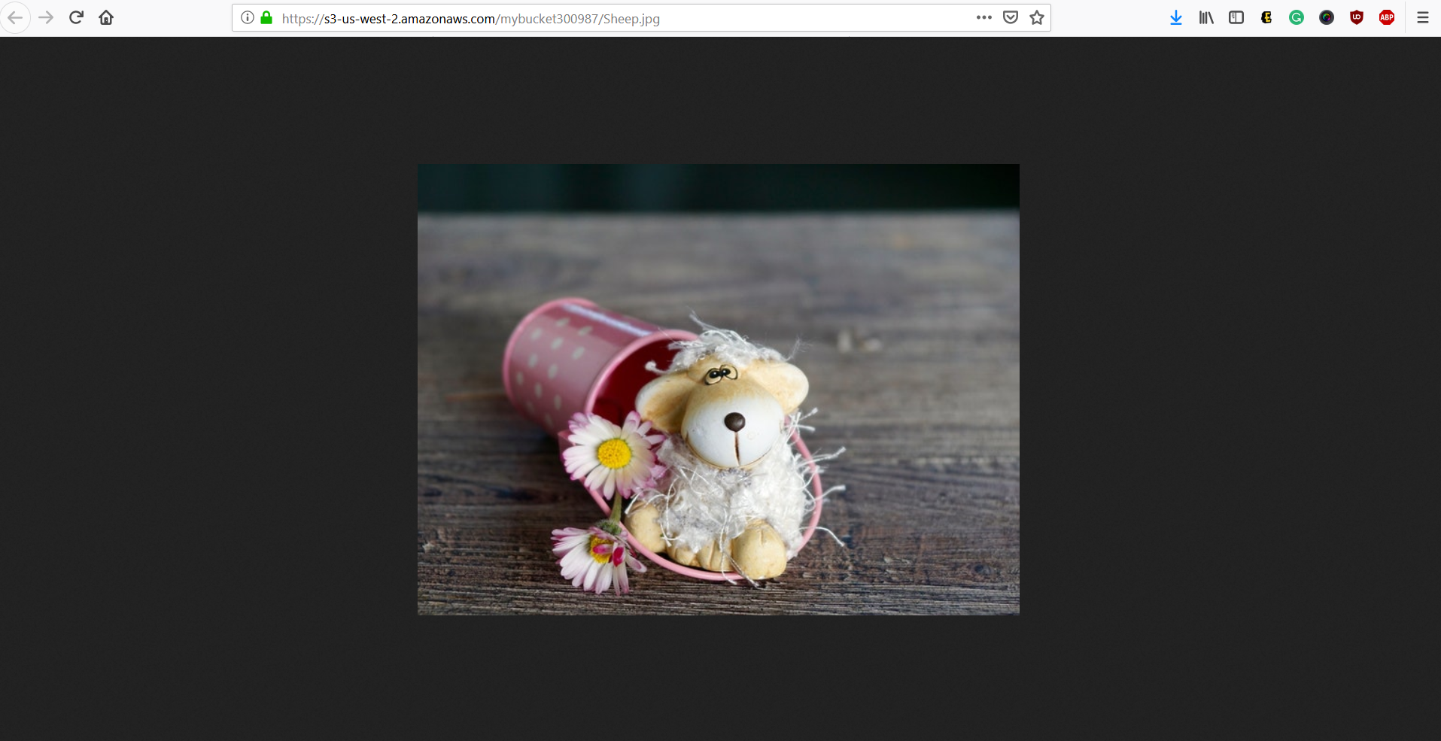

1. Create a Bucket Policy. One need to create a bucket policy if sets of permissions are needed for the entire bucket or set of directories
   1. Upload “Eiffel.jpg” in the same S3 bucket created above.
   2. One cant still access the S3 object – Eiffel.jpg publicly (Web browser)
   3. Click on S3 bucket name and click on Permissions Tab
   4. Click on Bucket Policy
   5. Copy the ARN of your bucket
   6. Click on Policy generator at the bottom of the page
   7. In the new window – AWS Policy Generator, configure the following: Type of Policy: “S3 Bucket policy” and principal: “\*”, Actions: “Get Object”, ARN: “Copied above”
   8. Click Add Statement
   9. Click Generate Policy
   10. Copy the generated policy in the bucket policy editor
   11. Open the “Eiffel.jpg” S3 link on web browser. One can access it now.

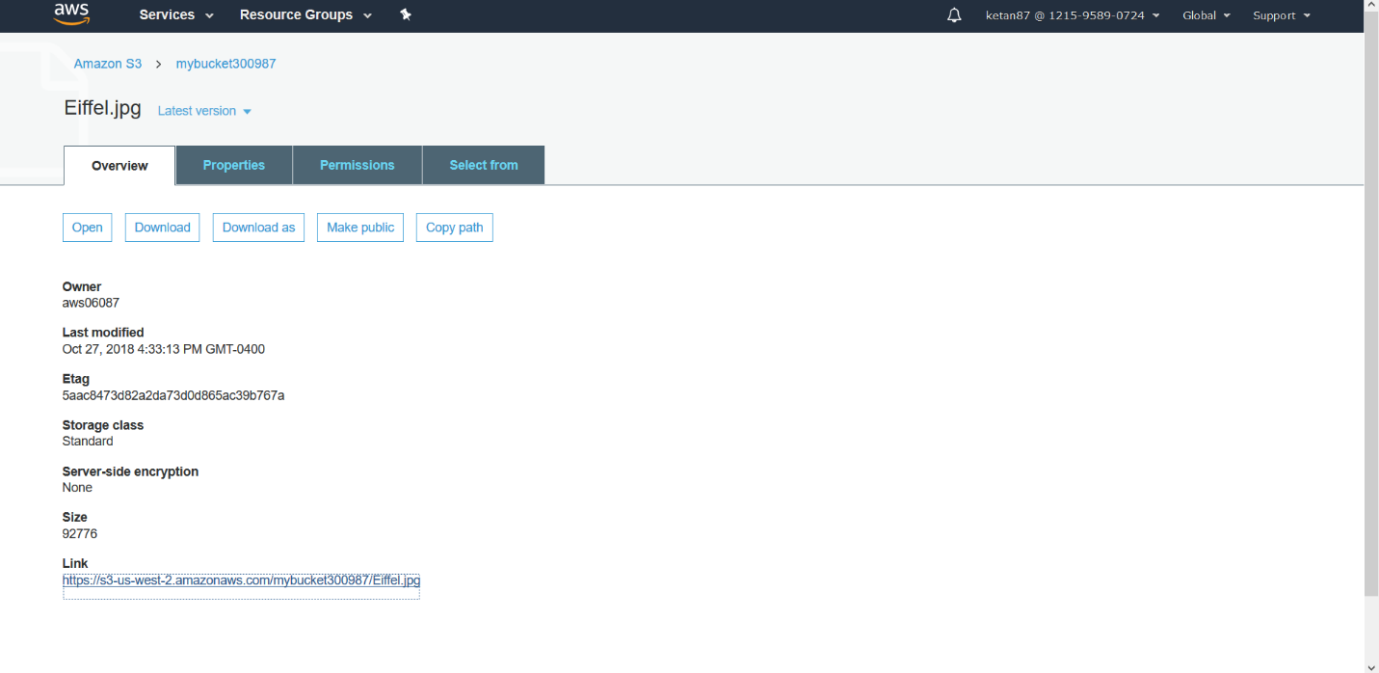

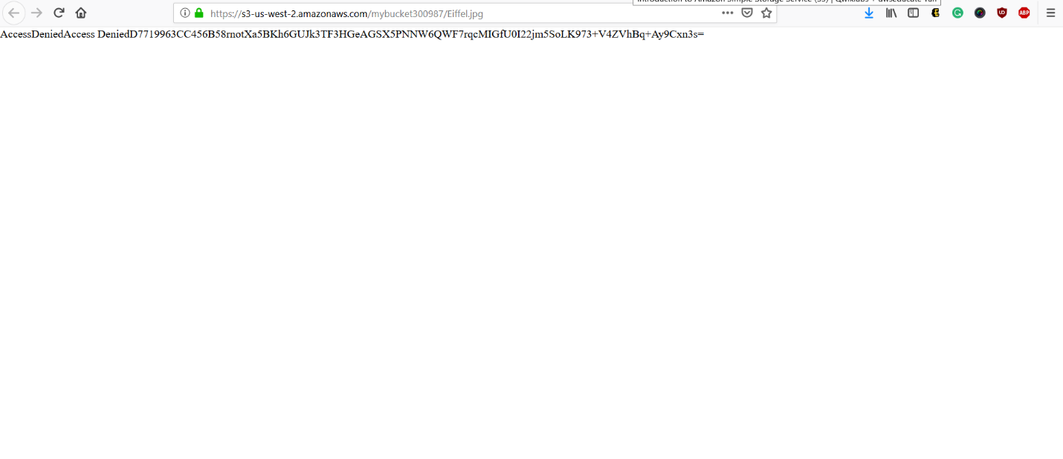

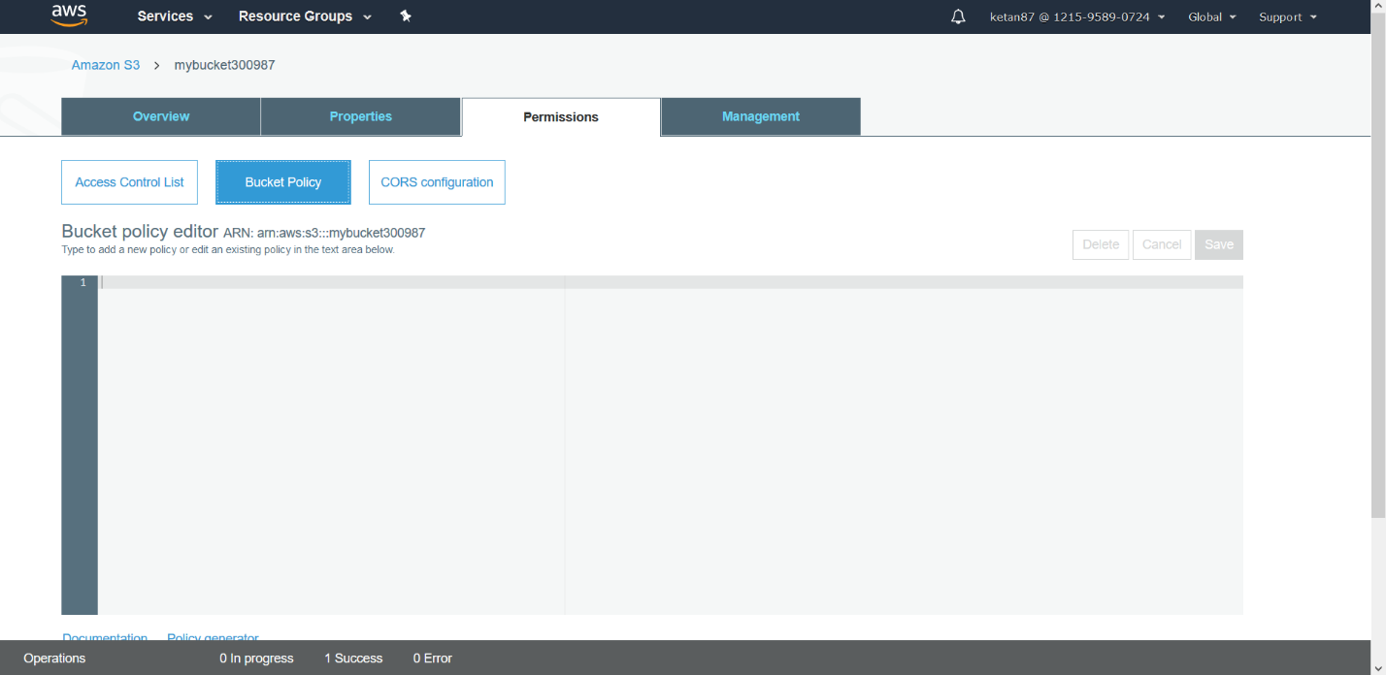

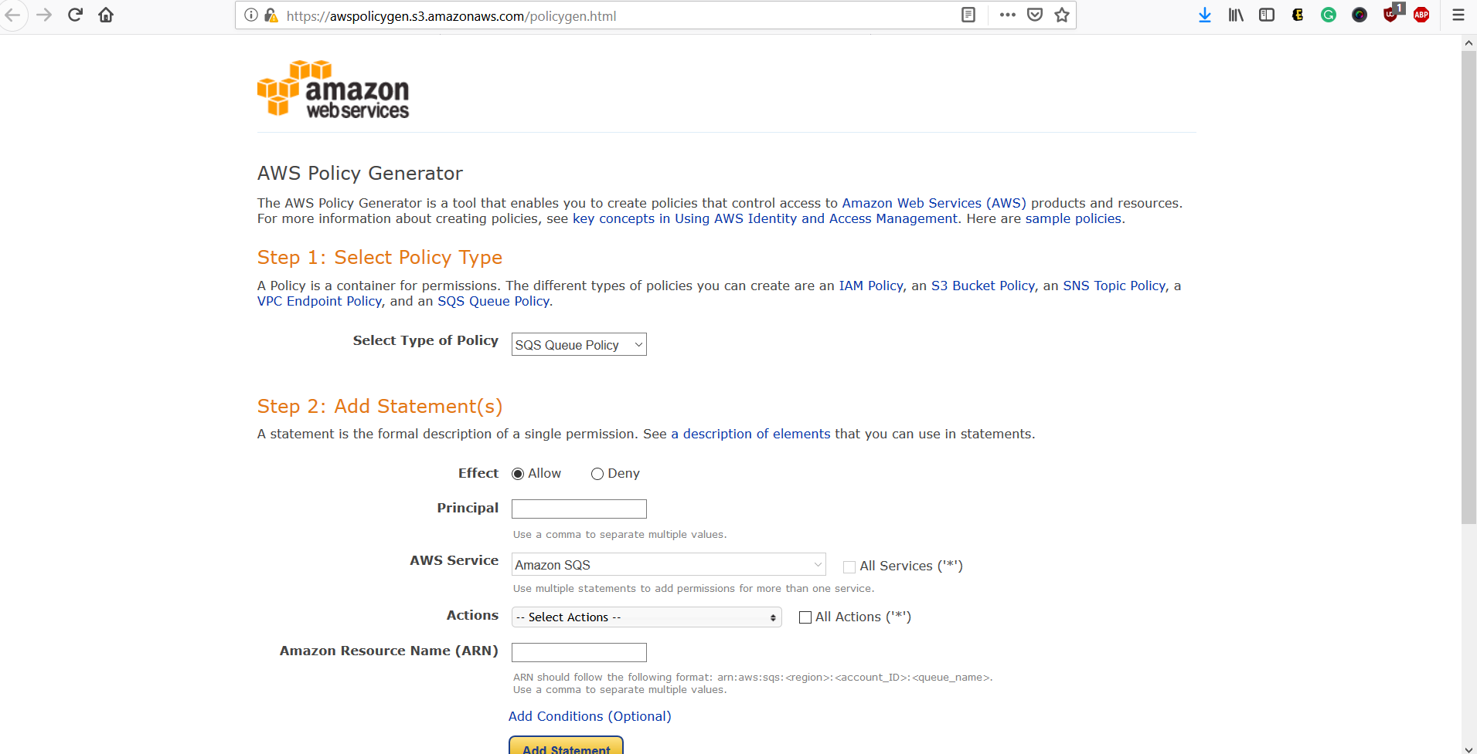

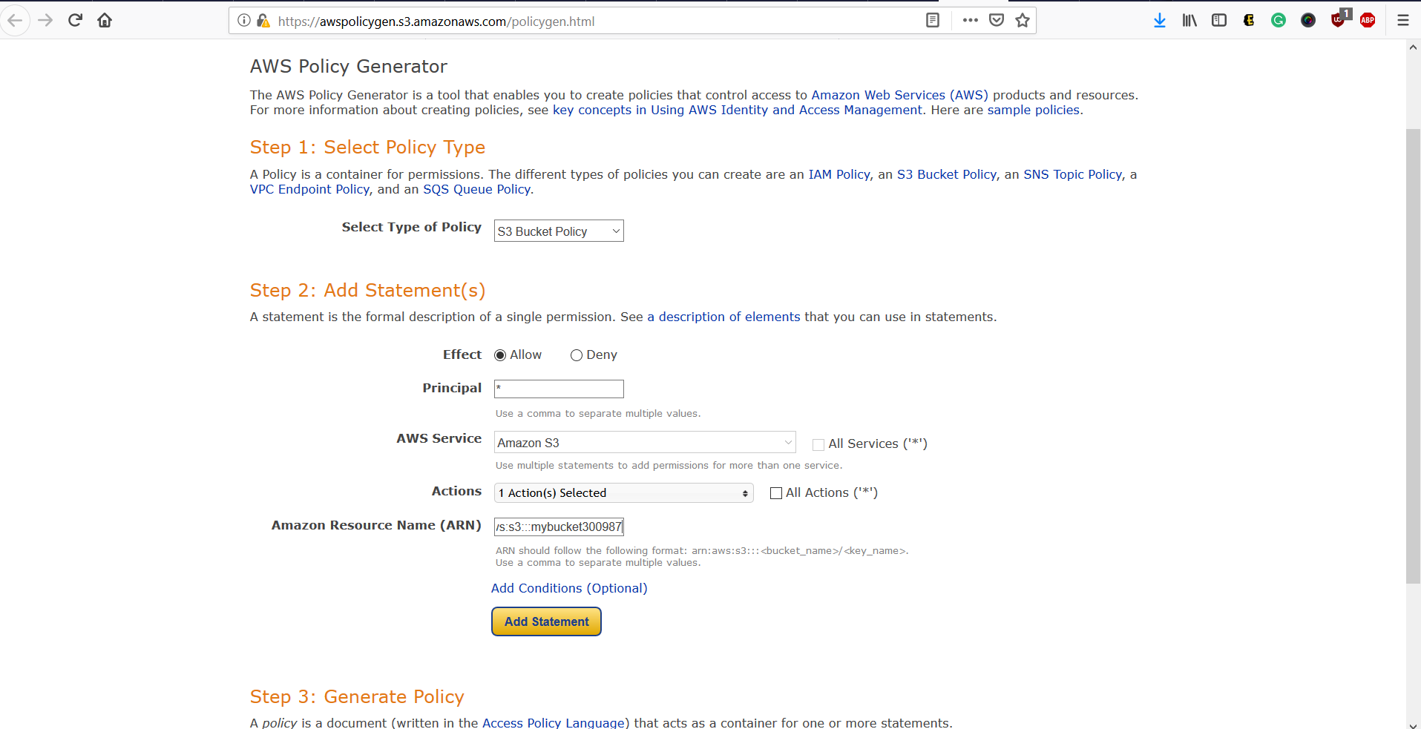

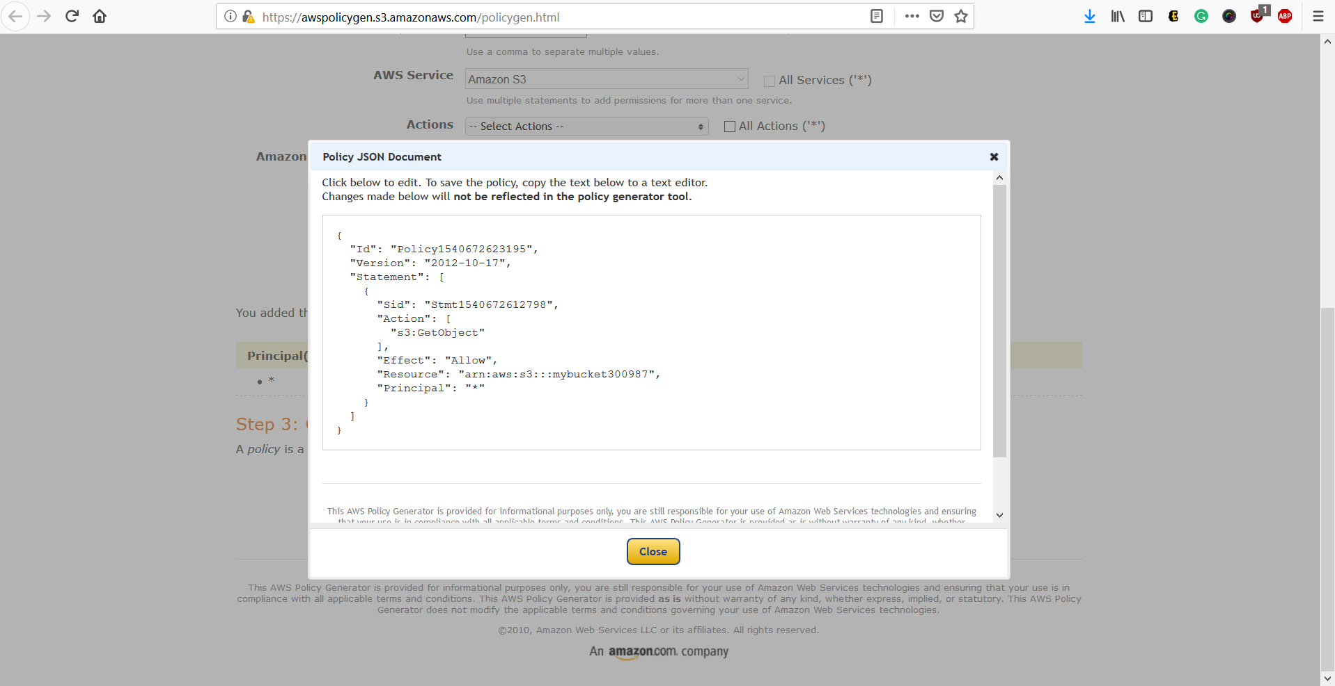

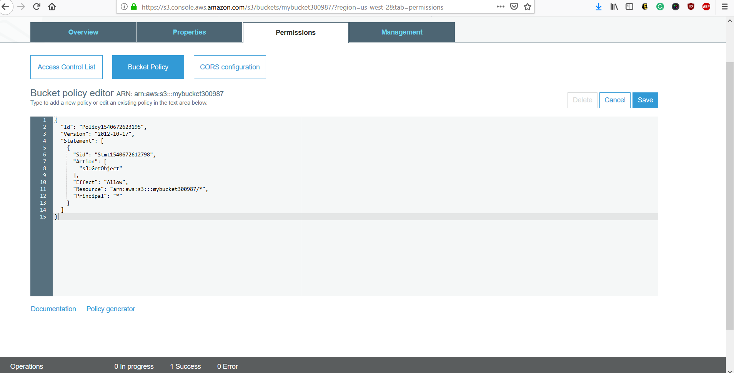

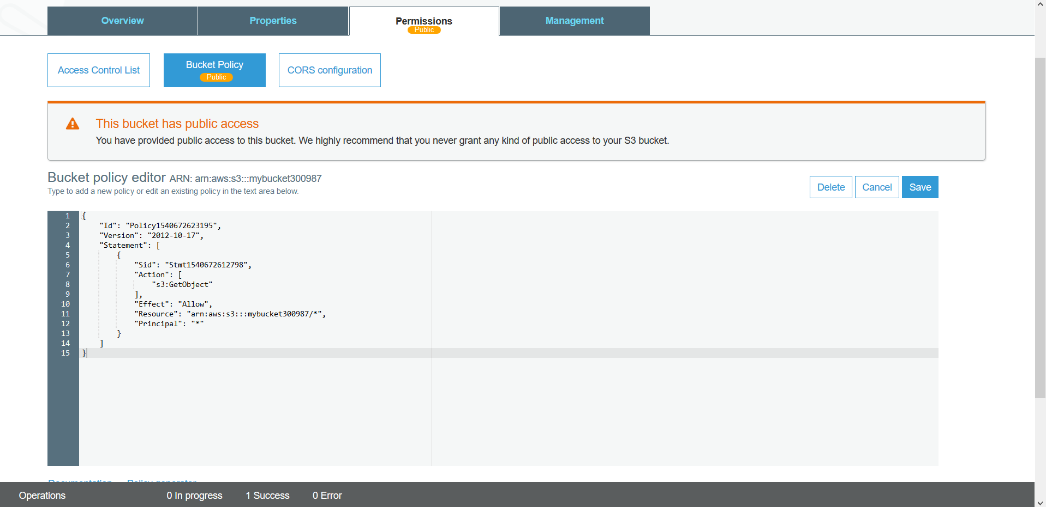

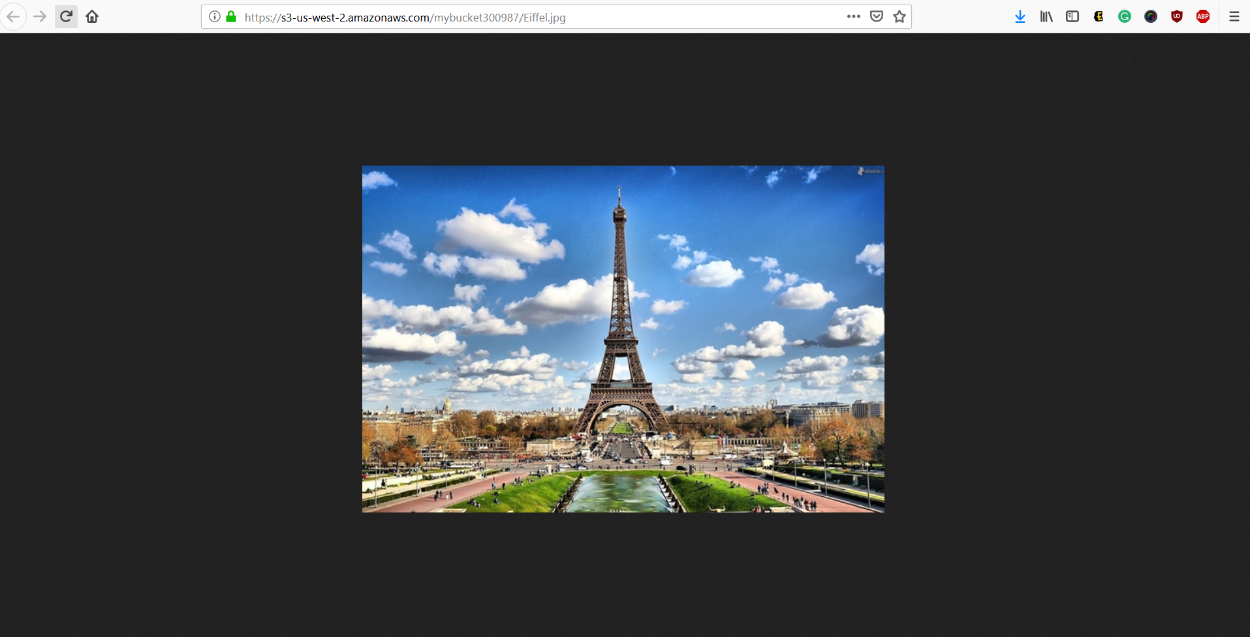

1. Explore Versioning. Versioning allows to preserves, retrieve and restore very object stored in S3 bucket
   1. Upload a different “Eiffel.jpg” object in the S3 bucket created above
   2. When opened in browser, the S3 link is updated with new image
   3. In S3 bucket, click on the Eiffel.jpg object. Explore the Latest version besides the object name and select the old version click Open
   4. You will see old object version

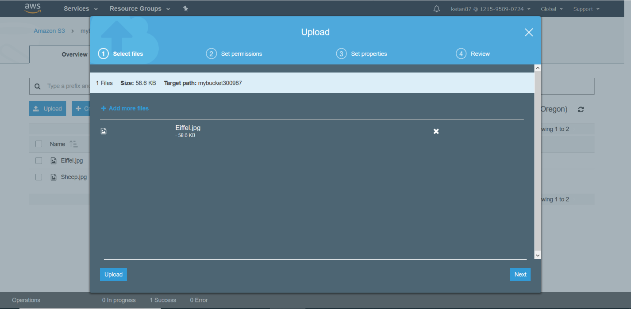

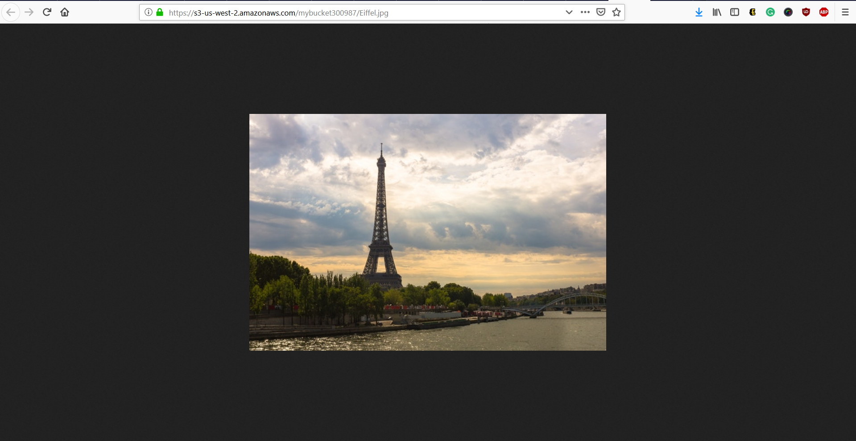

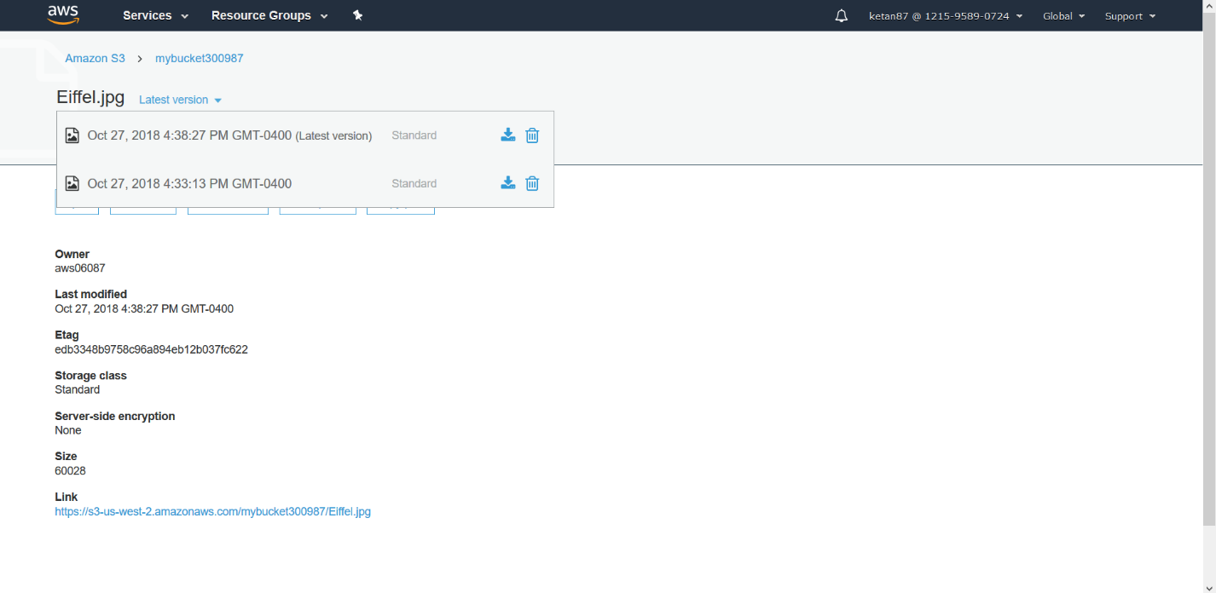

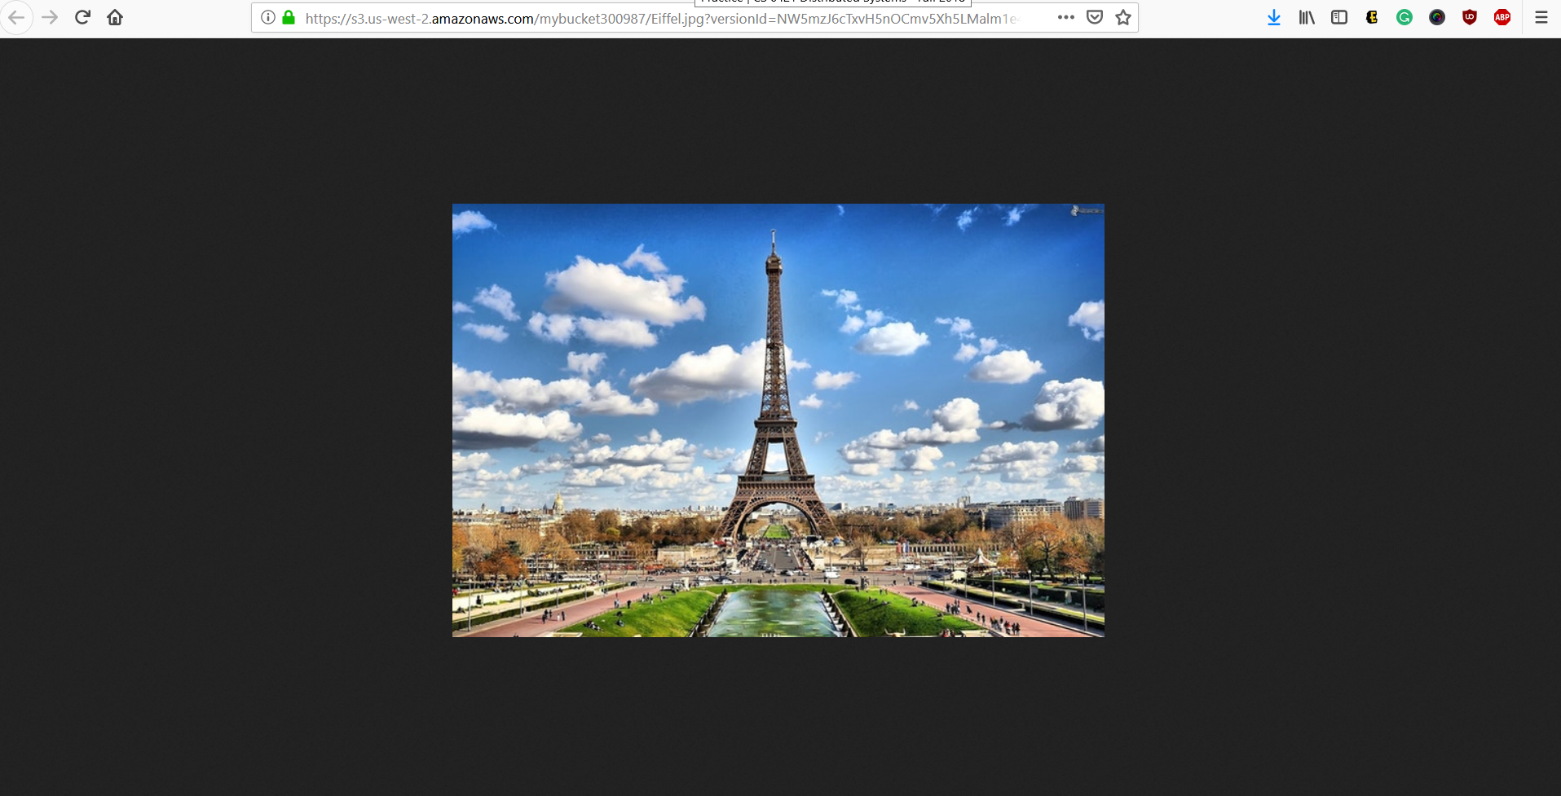

1. End Lab

Conclusion

We learned how to

1. Create a S3 bucket
2. Add an S3 object in the S3 bucket
3. Manage access permission of the object
4. Create a bucket Policy
5. Use bucket versioning

Total Time: 1 Hour 15 min